**Instructions for using the LoRa Radio library**

**I. Minimal hardware setup [STM32U031C8T6].**

1. Serial wire debug (SWD).

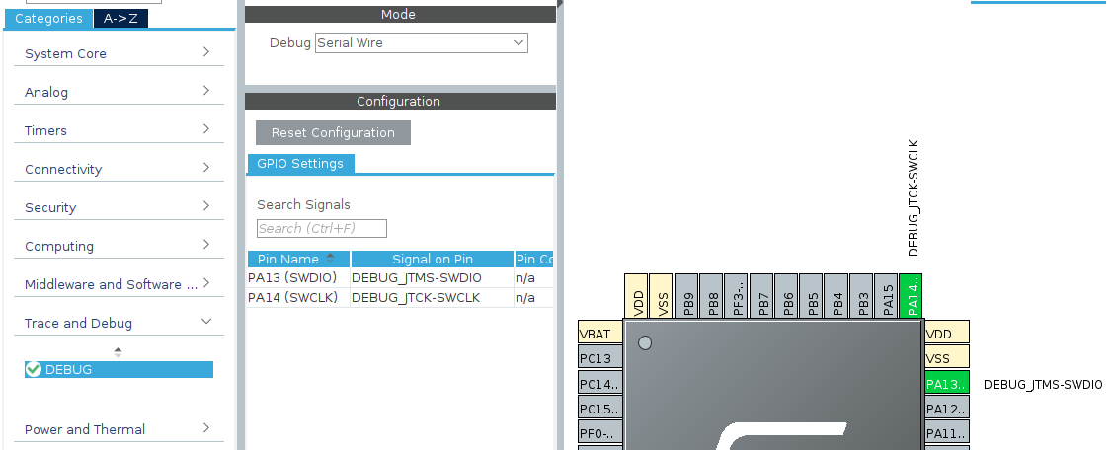2. System clock.

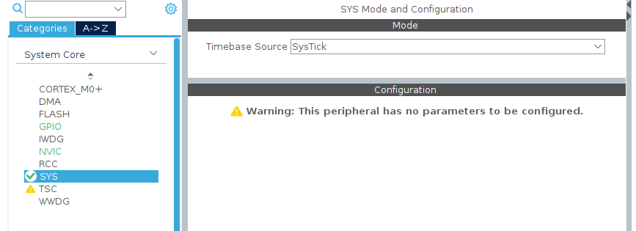

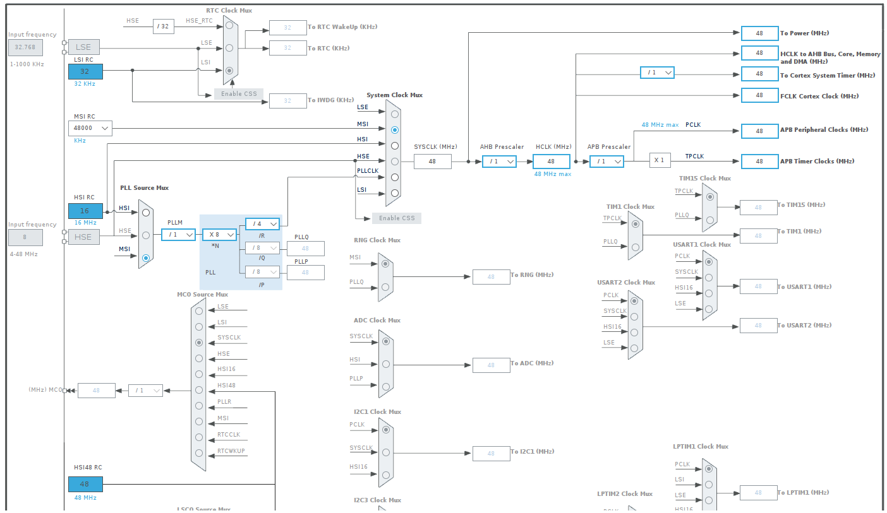

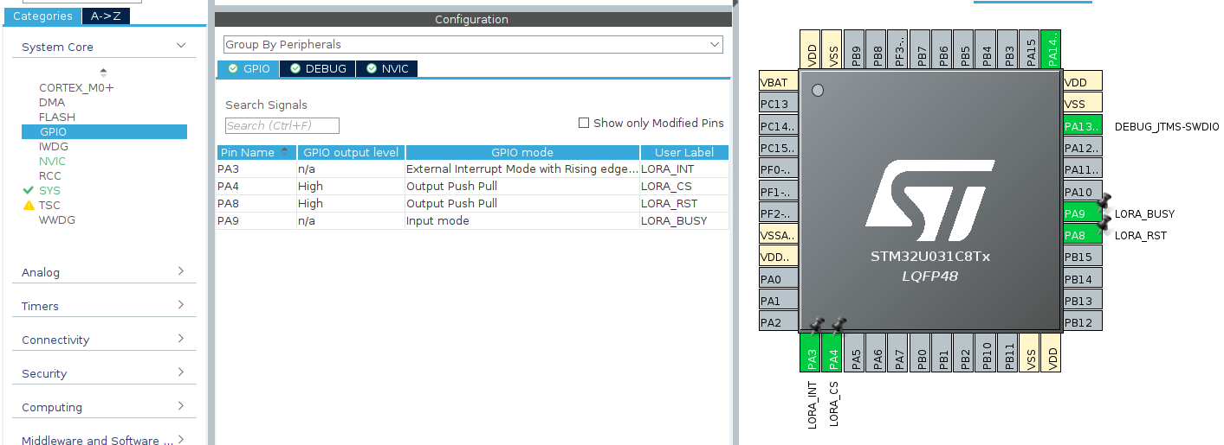3. GPIO interface with SX1262 chip.

You must label pin name the GPIO pins as shown to match the LoRa library.  
  
3. SPI interface with SX1262 chip.

- Mode: Full-duplex master

- Data size 8-bits

- Data order: MSB first

- Speed: Clock speed <=16MHz (BaudRate <= 16MBits/s)

- SPI interrupt: None

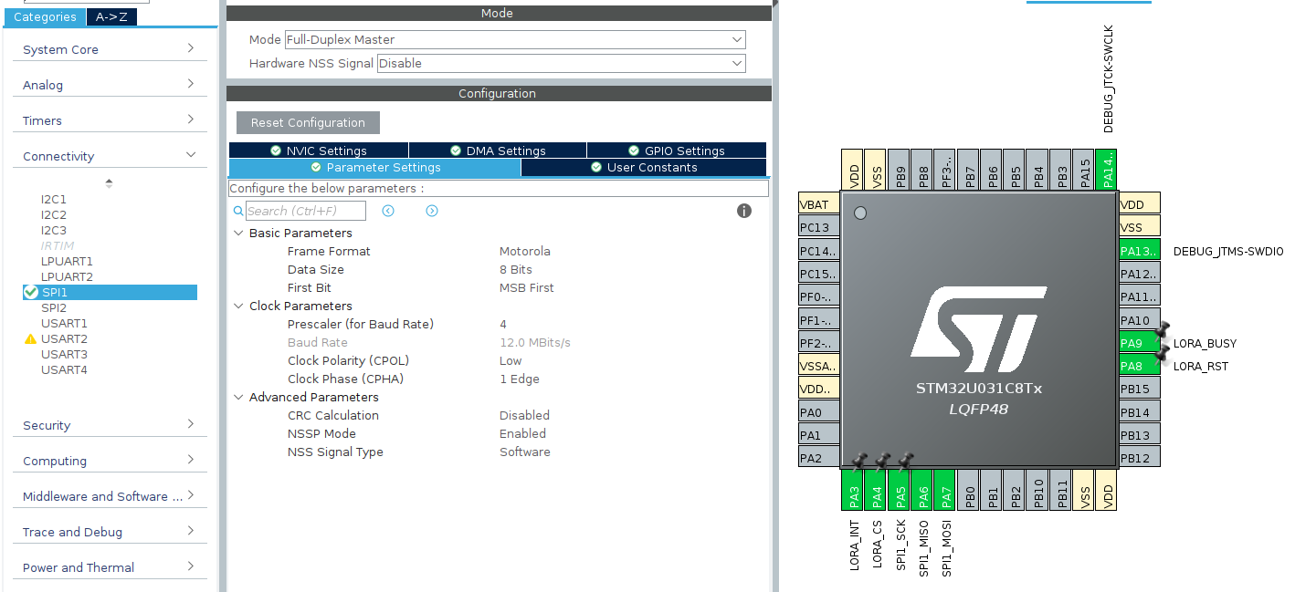**II. Project setup.**1. Copy libraries into project.

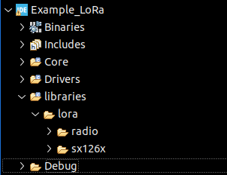

2. Change project properties.

- Add ../libraries to C/C++ build -> Settings -> MCU GCC Compiler -> Include paths

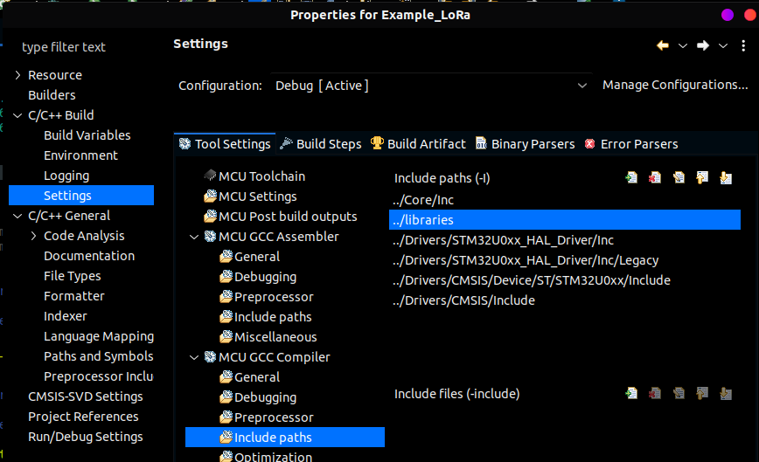  
- Add libraries folder to C/C++ general -> Paths and Symbols -> Source location.  
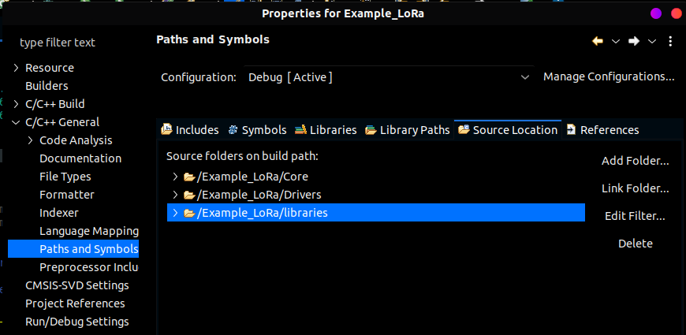  
  
  
  
- Set macro SX1262_SPI as SPI handle corresponding to the SPI used  
